Corrections:

1. Remove the word TOLL FREE and add both the phone numbers given in the flyers on the share drive.

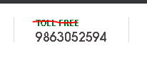

1. The 3 images in background need to be changed to some Indian student pictures like shown on <https://conceptasbclasses.co.in/conceptabsclasses/>. Also, remove the online MBA thing and what is written in French or Spanish – Lorem lpsum….



1. The dates are wrong so let’s no put any dates part



1. Important Links are being shown twice? It should be just once.

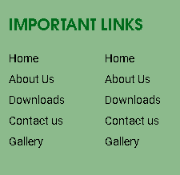

1. Why is this foreign thing still there???

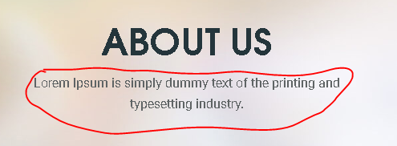

1. About the mentor should be left aligned; same like other headings on the page are left aligned. Please change the text font of the name and profile section under the photograph; it shouldn’t be same as the rest of the text font under “About the mentor” section.

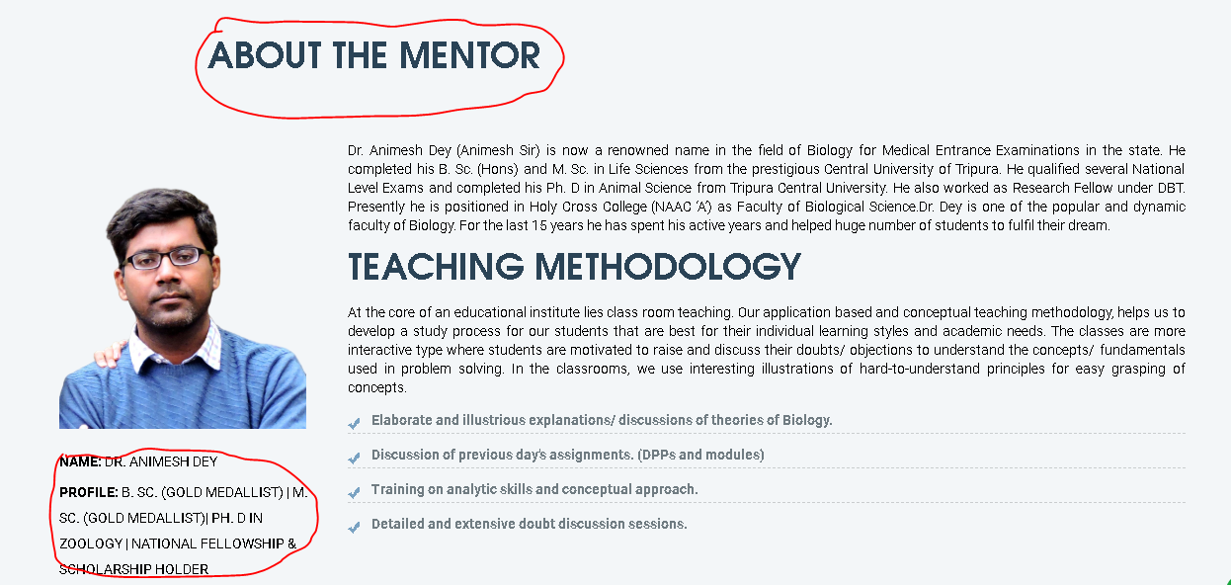

1. Our Courses page looks very plain and simple, it looks like a word document. I had already pointed out this last week to make this attractive and also had given reference of squaricletraining website. Why is this still such plain? Same goes for Online and Offline courses

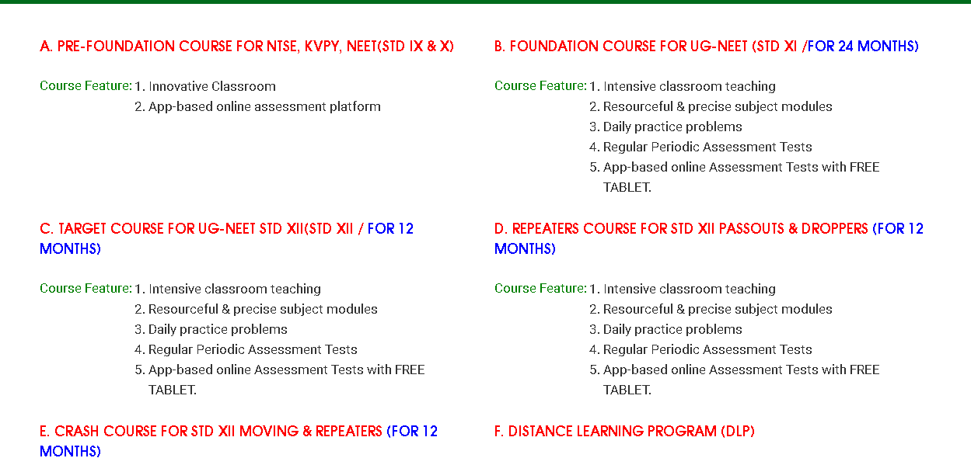

1. The social media handle please add the 2nd Facebook link also. And the link for G+ is wrong. We don’t have G+ link, the link provided is for Google Maps, so please remove it. Same things also needs to be done on the ‘Contact U’ page. We need 1 Instagram and 2 Facebook links here. Also, if possible please add a Whatsapp handle for the number?

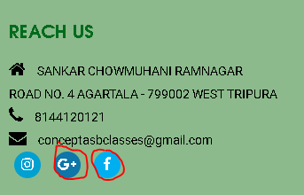

1. Edit functionality is not working in Downloads dashboard. I just tried to edit the name so in that case it should not ask me to upload the file again. But it is not allowing me to just edit the file name without uploading.

